Section 1

1. Create a database

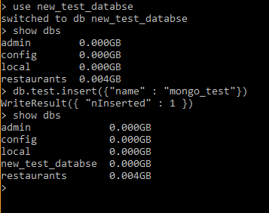

1. Drop a database

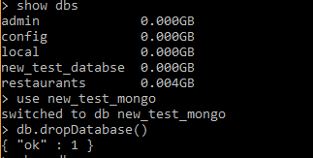

1. Creating a collection

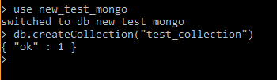

1. Dropping a collection

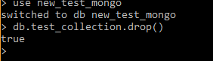

1. Insert a document



1. Query a document

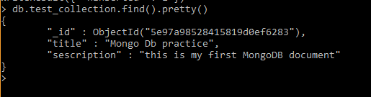

1. Update a document

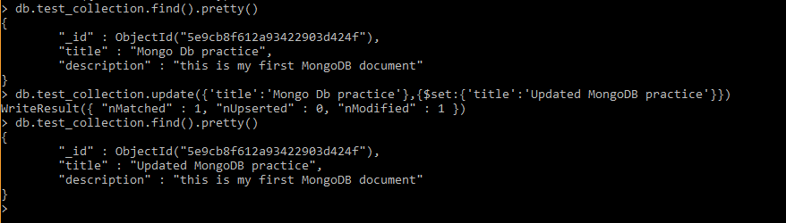

1. Delete a document

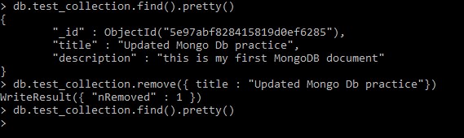

Section 2

Question 1:

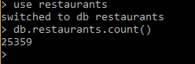

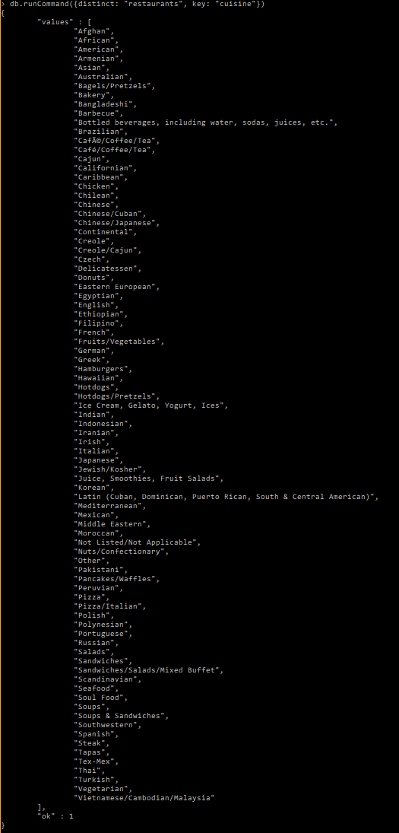Question 2:

Question 3:

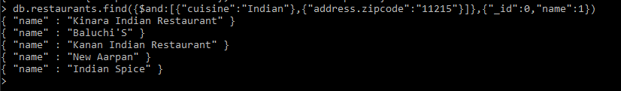

Question 4:

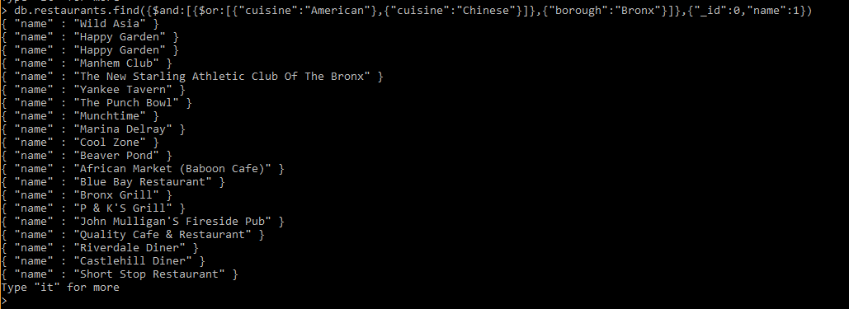

Question 5:

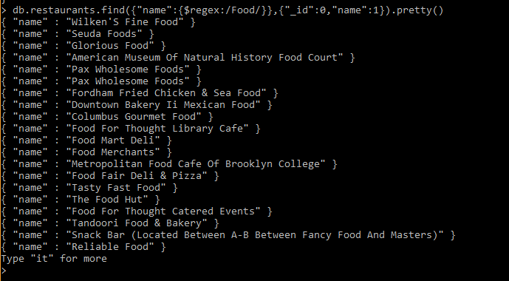

Question 6:

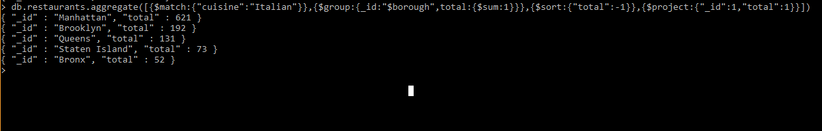

Question 7:

